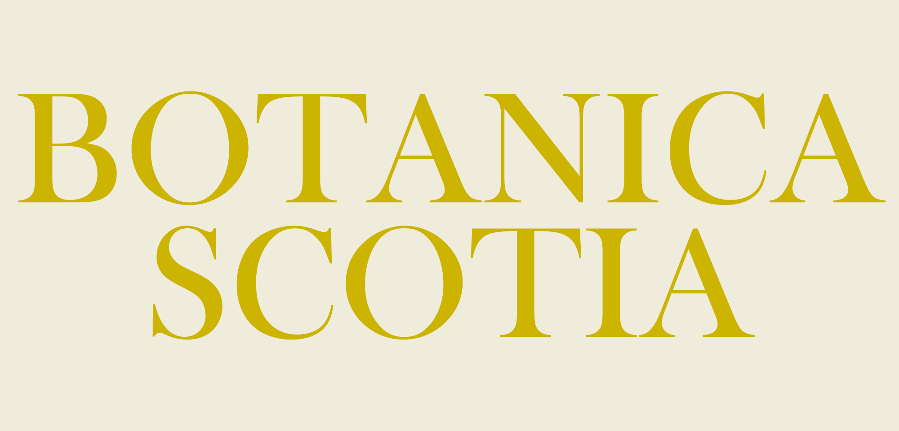
18th May 2025

INTENTION TO SUBMIT
Deadline - March 31st 2024

Please complete and submit this form via email to info@botanicascotia.uk

First name: Last Name:

Address:

Post code:

Contact telephone number:

Email address:

Please give us an idea of your chosen subject(s) and in which medium you will be working. Will your paintings be for sale? YES or NO delete one

- __________________________________________________________

- __________________________________________________________

- __________________________________________________________

Please sign here to indicate your consent to Botanica Scotia storing and potentially using your images for marketing purposes for this exhibition.

Signature:

Thank you
Ps please use extra space [keep typing]if you would like to add anything about the back story for your chosen subject[s]……………………………………….

